WEEK 1
Task1
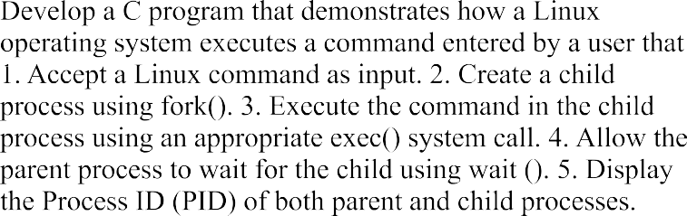

Source Code:
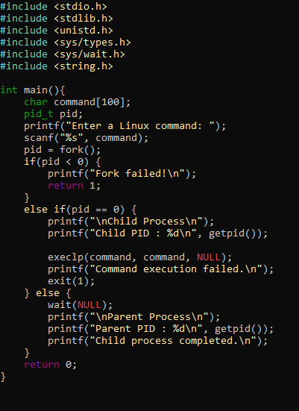

Output:
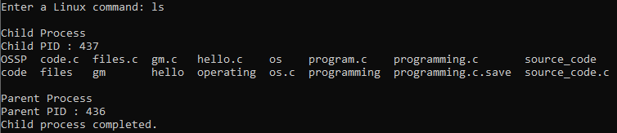

Task2
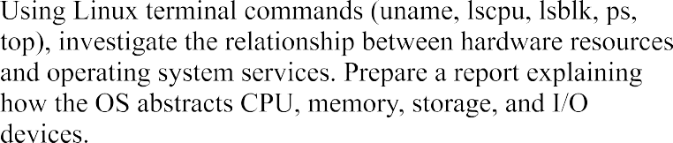
Report
- Uname: Displays operating system and kernel information.

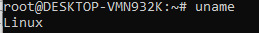

lscpu: Displays CPU information.

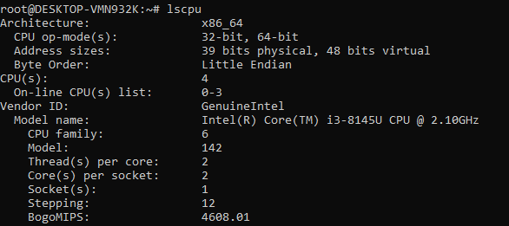

- lsblk: Displays storage devices.
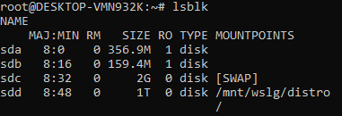
- ps: Displays currently running processes.
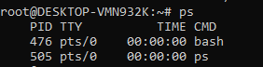

- top: Displays real-time system performance.
